Jack W. Gooding
Standing Chapter 13 Trustee

INSTRUCTIONS FOR DEBTORS TO CONNECT TO THE TRUSTEE’S
341 ZOOM PORTAL

The Trustee’s 341 Zoom Portal is a simplified way to connect to your Zoom 341 Meeting. Follow the instructions, below, to connect.

- Open your web browser on your computer or smartphone and go to the Trustee’s NDC zoom portal.

The website address is https://www.ndc.org/zoom/rock3

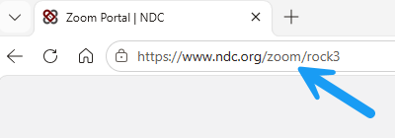

- Make sure that the party type of DEBTOR is highlighted, then click the down arrow in the box next to the words ‘Select Your Name’

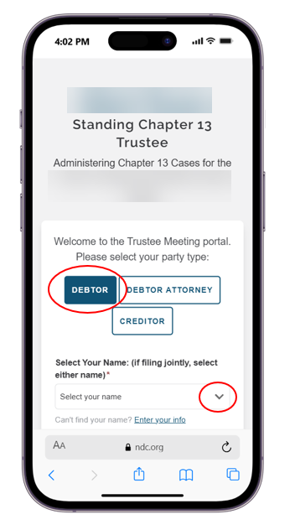

- Choose your name from the drop-down list. This will fill in your information. If your name is not on the list, go to step 5.

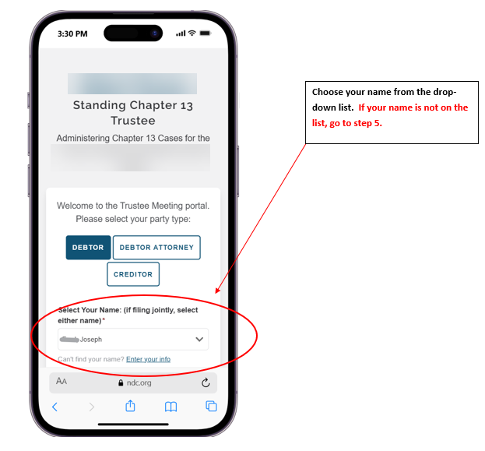

- If you would like to set up a free case monitoring account with the National Data Center (www.ndc.org), enter your email address.

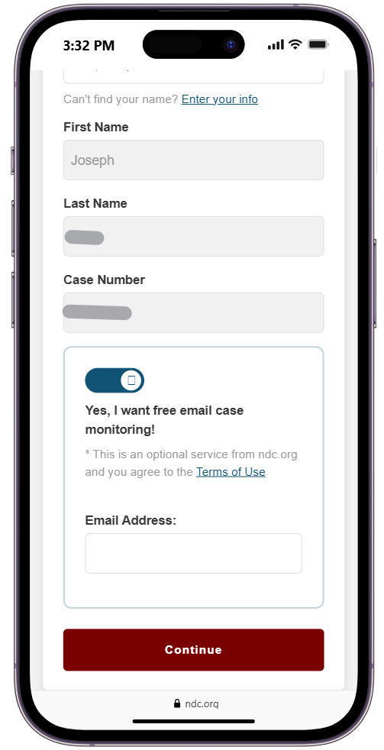
Use the toggle button to set up your free account at the National Data Center. If you choose yes, enter your email address here.
- If your name is not on the list, click the Enter your info link and enter your first name, last name and the last 4 of your Social Security Number. If you would like to set up a free case monitoring account with the National Data Center (www.ndc.org), enter your email address.

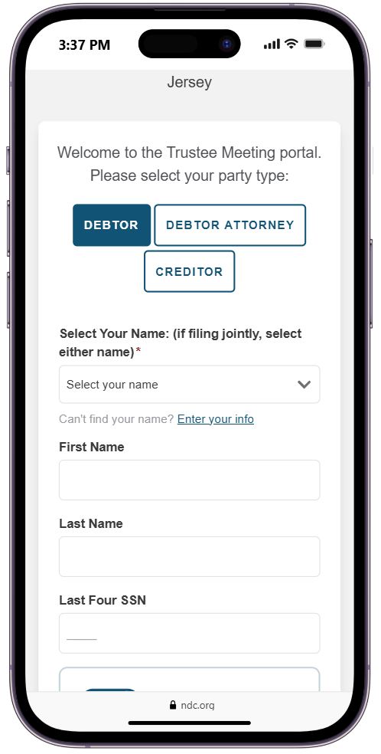
Can’t find your name in the drop-down list? Click here to enter it manually.

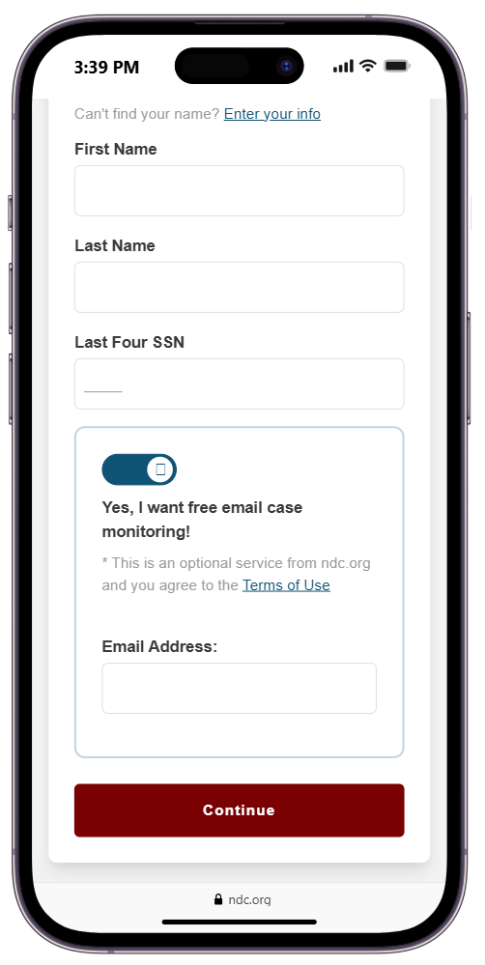
Use the toggle button to set up your free account at the National Data Center. If you choose yes, enter your email address here.

- Click the CONTINUE button

- You must click the AGREE & CONTINUE button on the notice that pops up on the next window.

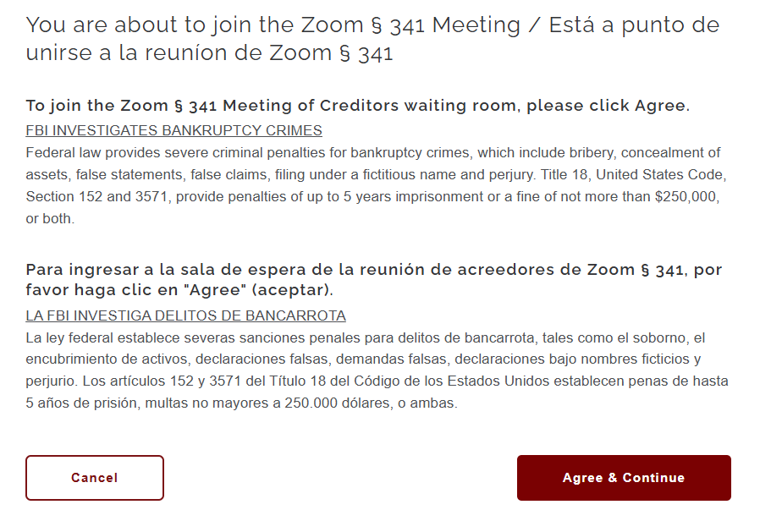

- Click ALLOW to allow microphone access and wait for the screen to confirm audio access.

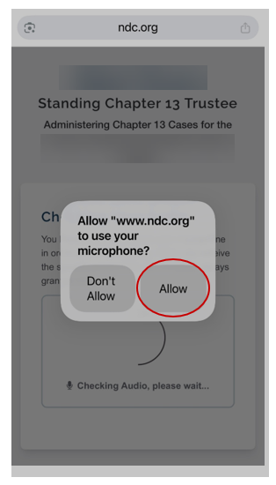
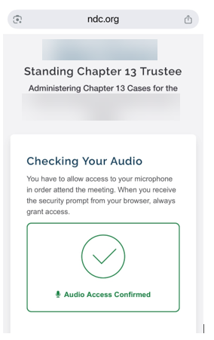

- Click ALLOW to allow camera access and wait for the screen to confirm video access.

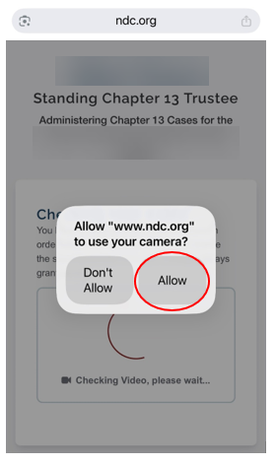
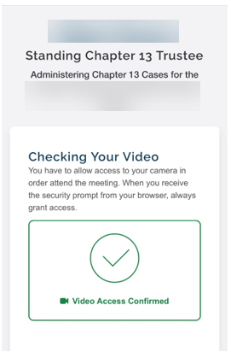

**YOU MUST ALLOW CAMERA AND MICROPHONE ACCESS IN ORDER FOR THE TRUSTEE’S STAFF TO SEE AND HEAR YOU***

- Agree to the terms by clicking the AGREE button.
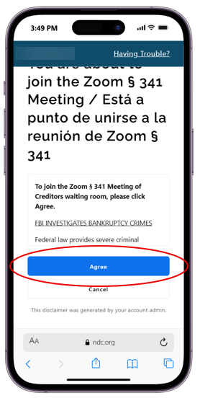

- Click the JOIN button to join the meeting. You will be placed in the waiting room. Wait there until the Trustee’s staff admits you to the 341 Meeting.

